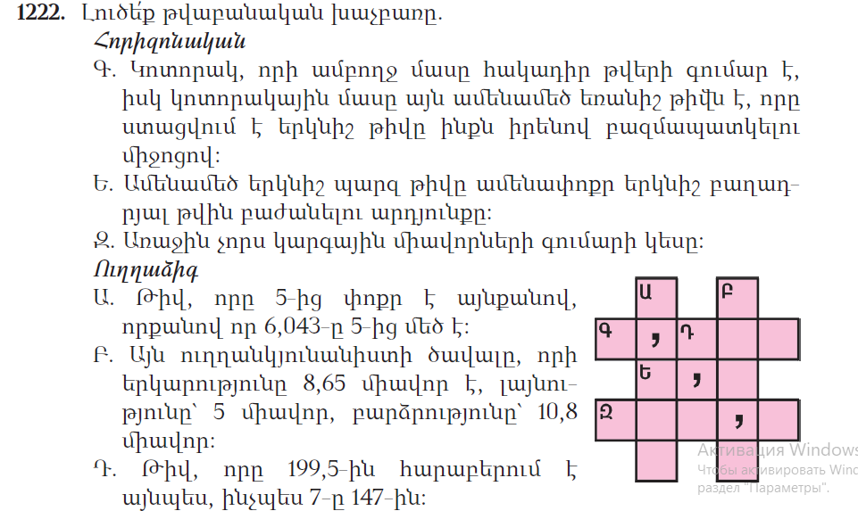
Գ․ 25x25= 625
26x26= 676
27x27= 729
31x31= 961
Ե․ 97:10= 9,7
Զ․ ???
Ա․
 |  | 6 | , | 0 | 4 | 3
 | - |  |  |  |  | 5
 |  | 1 | , | 0 | 4 | 3
 |  | 1 | , | 0 | 4 | 3
 |  | - |  |  |  | 5
 |  | 3 | , | 9 | 5 | 7
Բ․
 | 8 | , | 6 | 5
x |  |  |  | 5
4 | 3 | , | 2 | 5
 | 4 | 3 | 2 | 5
 |  | 1 | 0 | 8
3 | 4 | 6 | 0 | 0
0 | 0 | 0 | 0
4 | 3 | 2 | 5
4 | 6 | 7 | , | 1 | 0 | 0
Դ. 147:7= 21
199,5:21= 9,5

